1. To examin fin and syn I apply the following query In filter of wire shark that is attached in snap of syn , fin

**tshark -r testtrace.pcap -R "tcp.flags.fin==1" -n -Tfields -e tcp.stream**

1. Test TCP screen shoot

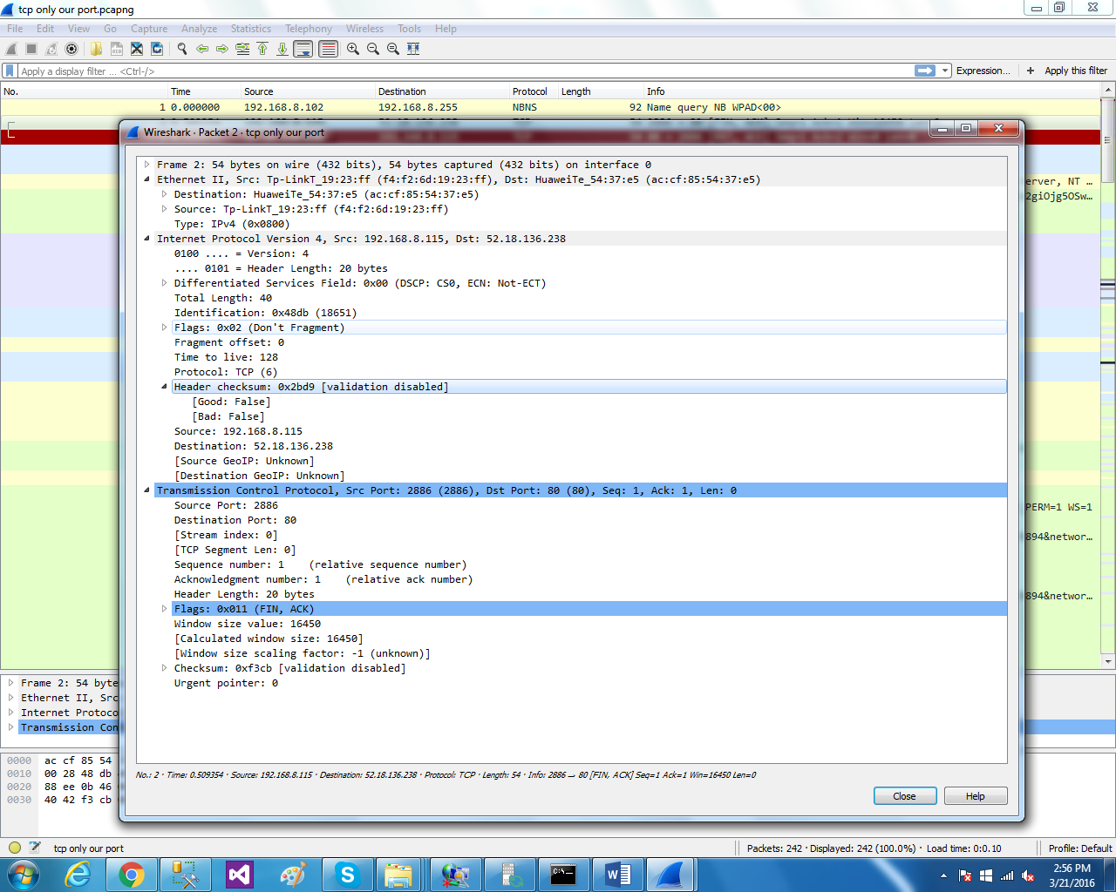

**that gives the port also as you see in screen shoot 80**

1. **Configured telnet server in win features on off**

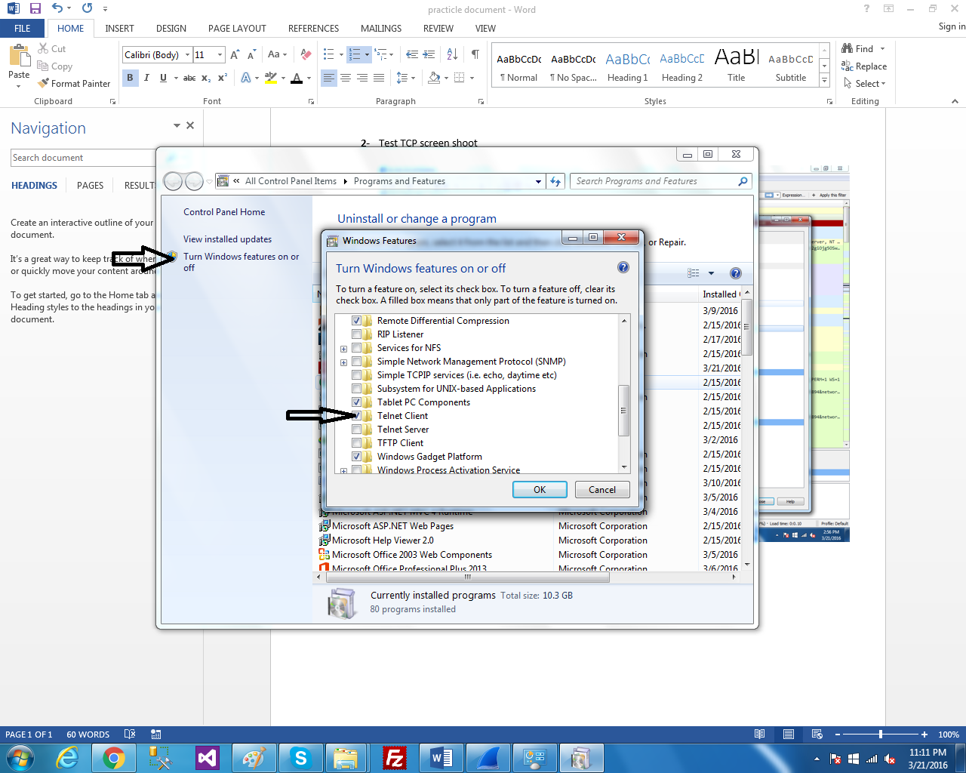

1. Configured the ftp server using ftp lite

